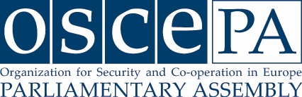

MEETING OF THE BUREAU

Copenhagen, 22 – 23 April 2012

P R O G R A M M E

Sunday, 22 April

17:00 -18:30 Open house (registration of participants and reception) in the premises of the International Secretariat of the Parliamentary Assembly of the OSCE
Tordenskjoldsgade 1, 1055 Copenhagen
Tel: +45 33 37 80 40
(International Secretariat will open at 15:00)

18:30 Departure by bus from the Hotel Marriott / walking from International Secretariat

19:00 Dinner hosted by the Head of the Danish Delegation to the OSCE PA for the participants in the meeting of the Bureau of the OSCE Parliamentary Assembly
Restaurant TBC

Departure by bus to Hotel Marriott

Monday, 23 April

08:30 Departure by bus from Hotel Marriott

09.00 Meeting of the Bureau of the OSCE Parliamentary Assembly
(Location: Folketinget)

11.00 - 11.30 Coffee break

11.30 - 14.00 (approx.)Cont. Meeting of the Bureau

14:00 (approx.) Closure

14:00 Buffet lunch for all participants offered by the Danish Delegation to the OSCE PA (Folketinget)

15:30 Departure by bus to Hotel Marriott

* * * * *

